CrashAlert/ScanNShow: Enhancing Peripheral Alertness on Mobile Devices for Multi-tasking while Walking

Anonymous 1 | Anonymous 2

ABSTRACT
Divided attention resulting from multi-tasking while walk-ing (e.g. texting, browsing the web, etc) can lead to danger-ous and sometimes life-threatening outcomes such as colliding into obstacles or other people. To avoid such risks we introduce a novel system that extends peripheral awareness through sensors embedded on mobile devices and that provides visual cues of the environment in a minimal footprint display on the device. We present CrashAlert, a system to enhance peripheral alertness and reduce the risk of collisions when walking and multi-tasking with mobile devices. We augment a mobile device with a depth sensing camera that alerts the user to the existence of obstacles outside the user’ periphery. We present the design and evaluation of CrashAlert… In an evaluation outside a lab environment, CrashAlert…
Other names: PhoneBumper / BumpAlert / CrashAlert / BumpAware / CrashAware
ACM Classification: H5.2 [Information interfaces and presentation]: User Interfaces. - Graphical user interfaces.
General terms: obstacle avoidance, multi-tasking, eyes-on interaction,
Keywords: Eyes-busy interaction, texting and walking, walking user interface.

INTRODUCTION
Mobile device users habitually multi-task (such as entering text or conversing) while walking [refs.]. Unfortunately, tasks that require a high degree of visual attention or eyes-busy interaction (such as texting) limit much of the user’s peripheral vision. Such practice has resulted in user’s tripping onto curbs, walking into traffic or deviating from their intended path [refs.]. Eyes-busy interaction while walking has led to a threefold increase in emergency room cases [ref.], forcing some states to introduce new safety policies that ban mobile device usage while walking [ref.]. However, aside from policy making, new technology for safer walking and multi-tasking is relatively unexplored.
In this paper, we introduce CrashAlert, a system that captures and displays information beyond the user’s peripheral view, using a depth camera attached to a mobile device. CrashAlert has two components: it scans the environment for obstacles that are on the user’s path, and then alerts users about the position of these objects in a minimal footprint display on the mobile screen. Numerous visual representations of the depth image are possible and our impWe implemented various visual transformations on the scanned image to keep the CrashAlert’s display at its best minimum size. [list some sample image transformations here.].
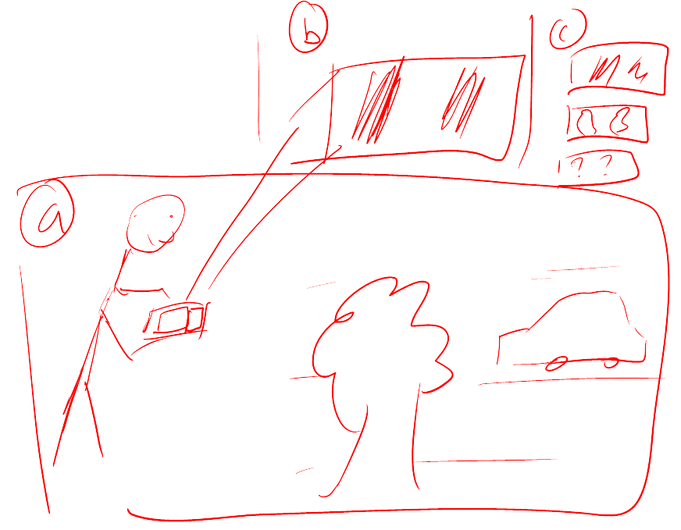
Permission to make digital or hard copies of all or part of this work for personal or classroom use is granted without fee provided that copies are not made or distributed for profit or commercial advantage and that copies bear this notice and the full citation on the first page. To copy otherwise, to republish, to post on servers or to redistribute to lists, requires prior specific permission and/or a fee.
UIST’12, October 7-10, 2012, Cambridge, MA, USA.
Copyright © 2012 ACM 978-1-xxxx-xxxx-x/xx/xx... $10.00.
Figure 1 – CrashAlert senses environmental obstacles, including static and moving objects and informs users of the positions of these objects in a minimalistic and configurable manner on the user’s display. Alerts are triggered when the user is quickly approaching an object.
We evaluated CrashAlert in an obstacle avoidance task outside a lab environment. Twelve participants walked through a cafeteria during its peak times. We also planned specific obstacles unknown to the participants, such as facing on comers or being cut-off. Qualitative data suggests that participants felt safer using CrashAlert and our observations indicated that users were proactive in avoiding obstacles. Participants also walked faster and performed their task more efficiently with ChrashAlert. Overall, participants welcomed our augmentation for its ability to convey highly expressive information.
The main contribution of this paper is a demonstration that augmenting a mobile device with additional sensors, such as a depth sensing camera along with a minimal footprint visual display of the sensor’s data can assist users in eyes-busy interaction- while walking. This contribution comes in three parts: (1) a mobile system, CrashAlert, augmented with a depth sensing camera, (2) a set of visual transformations aimed at minimizing screen space and optimizing relevant environment information, and (3) an evaluation of CrashAlert showing improved multi-tasking performance while walking.

Related work
We first report on the dangers of multi-tasking in motion due to limited peripheral alertness and then briefly describe systems aimed at improving eyes-busy interaction while walking (such as walking and texting). CrashAlert’s primary objective is in assisting users with avoiding collisions while in motion and we therefore briefly report on assistive technologies for visually-impaired users or for visually-impoverished conditions.

Dangers of multi-tasking and walking
Field studies examining the effect of cell phone use on street crossing behavior have observed that pedestrians cross more slowly when conversing on a cell phone, are less likely to look at traffic before entering the roadway, and make more unsafe crossings compared to non-distracted pedestrians [refs.]. More recently, studies have shown that users can deviate significantly from their walking path when texting and walking [ref.] and hospital reports confirm an increased number of emergency incidences related to mult-tasking/texting while in motion [refs.]. Researchers have also controlled environmental factors (i.e. car speed, traffic density) in virtual reality settings and results confirm the negative effects of multi-tasking while walking [ref. The effects worsen with more demanding tasks: pedestrians are less likely to successfully cross a road and take more time to initiate a crossing when conversing on a cell phone than when listening to music.
Results from these studies have mostly guided the efforts of policy makers but also motivate the need for novel technological interventions. Furthermore, while VR studies can control many environmental conditions, we purposefully evaluated CrashAlert in the field to evaluate the potential risks and benefits of providing users with peripheral alertness.

Walking user interfaces
A new line of research in walking user interfaces [ref.] has emerged with the goal of studying and exploring methods to assist users with eyes-busy tasks while walking. Such interfaces have mainly concentrated on aiding users in being more efficient and accurate (therefore indirectly safer) with cognitively demanding tasks such as text-entry when walking. Recent results suggest that audio feedback [ref.] and gestures that start from the device’s bezel [ref.] can better guide touch-screen input while walking. Furthermore, to aid users with text-entry while walking, researchers have introduced systems that automatically enlarge soft buttons when in motion [ref.], systems for two-handed chorded keyboard input with a stylus [ref.], and novel adaptive methods that leverages a mobile device’s tri-axis accelerometer to compensate for extraneous movement [ref.].
Relatively fewer technological interventions have been proposed to enhance peripheral alertness while multi-tasking and walking. These are limited to directly displaying on the screen the video feed from the mobile’s camera (WalkNGo) or with some limited processing to show on-coming vehicles (X). To the best of our knowledge CrashAlert is the first system to exploit transforming images from a depth camera to provide visually salient information onto a minimal footprint display.

Guidance systems for visually-impaired users and visually-impoverished environments
Haptic/audio
Navigation systems with haptic/tactile feedback
Sonar sensors
Feeback through audio or haptic, which are generally considered to be mostly processed serially or to some extent spatially [ref.].
Firefighters, pilots, rescue

Research Approach
The goal of our research is twofold. First, based on observations of actual behaviors of users’ interacting with mobile devices while on the go, we propose a technical solution to the problems derived from the users’ limited attention. Second, we explore the design implications for technologies aimed at alleviating the same problem. In the first phase… [we did fieldwork observations, derived a series of desing implications, built a prototype, and evaluate it]
In the second phase… [we generalize from our experience proposing a design space definition and discuss some of the venues for future research]

Field observations
In order to better understand how users of mobile devices engage with them while on-the-go we carried out an observational study in public places. We observed over forty users in a university cafeteria and at a shopping center perform activities on their mobile devices while walking. We recorded the holding angle of the device, the number of hands used, the number of steps taken before lifting their heads [to detect on-comers and obstacles], walking patterns in slowing or speeding up, whether they had company, whether they typed, and whether the interaction ended in a phone call. Our data collection was limited to an indoor setting and its probably that different outcomes would have been obtained by collecting data from outdoor settings as well. However it constitutes a good basis for understanding some of the behavioral phenomenon taking placed while working and walking.
Our results helped identify … [average tilt angles], [average number of steps], [avoidance strategies: dodging, heads-up, stopping], […].
These observations led to the following design implications:
[R1] - Different angles of tilt
[R2] - Not for when it’s crowed or known route but rather for the unexpected [someone stopped or crossed in front of them]. Focus on the user crashing into something and not on something crashing into the user.
[R3] - Trigger head ups.

CrashAlert
Figure 2 presents CrashAlert, a system designed to provide users with ambient visualizations and visual alerts to help them avoid obstacles while multitasking on their mobile devices. CrashAlert uses both a depth and a normal camera to capture a region of space that lies outside the users field-of-view; this slice of the image is processed and presesented to the user on his mobile device.
To support the three requirements presented in the previous section, CrashAlert has three main components: a sliding window, an ambient visualization and visual alerts for approaching objects. R1

R2
CrashAlert seeks to consume minimum space on the mobile screen while providing maximum alertness to users.
R3 Visual Alerts

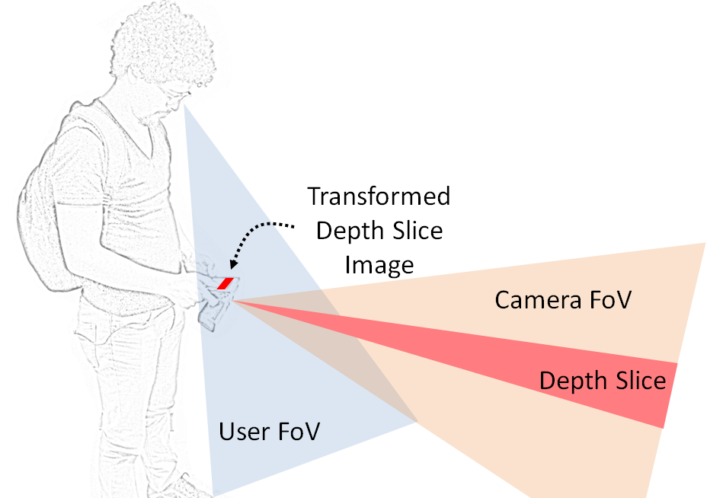
Figure 2 –A depth sensing camera can assist in extending the user’s limited peripheral view. Minimal processing on the a slice of the depth image, or depth slice, can reveal salient information about the environment. Our implementation allows for an adjustable height and position for the Depth Slice.

Implementation Details
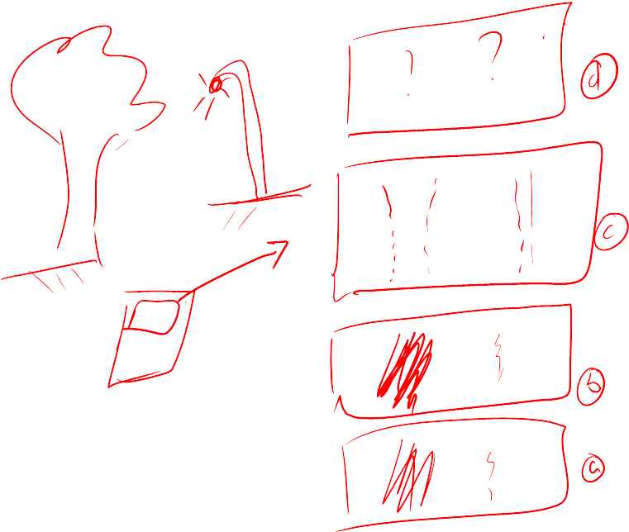
Figure 3 – Visualization types based on given scene. [Random ones, update with actual mappings] (a) Raw color image from the camera; (b) ClosestOnly shows the location of the closest object captured from the scene; (c) DepthRange displays the contents within a given range away from the user; (d) DepthMask applies the ClosestOnly or DepthRange as a mask on top of the raw color image to provide context of the object being seen.
Software

Hardware
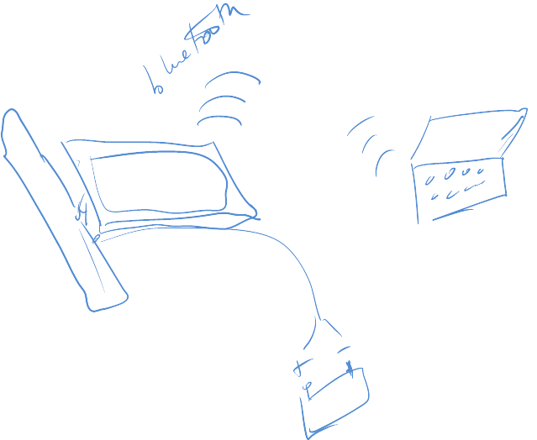
Figure 4 – Mobile tablet augmented with a Kinect depth sensing camera and, both communicating via Bluetooth to a laptop. The Kinect is powered using a 12 V battery and inverter.

EVALUATION
Our experiment was designed to determine if users could avoid obstacles while multi-tasking in a naturalistic environment. We recruited participants who habitually text and walk from within our university. We recruited thirteen university students (X male, Y female, mean age of 25.5 years) from various disciplines, including computer science. We first surveyed them about their texting and walking patterns, and X% said they do this often, another Y% indicated that a tool for texting and walking would encourage to text and feel more safe, and W% … We wanted participants to be genuinely busy and walk naturally.
We conducted a counterbalanced, within-subjects experiment in which participants were exposed to five conditions: (1) no feedback, (2) camera alone feedback, (3) feedback #1, (4) feedback #2. We selected feedback # 1 and #2 as they are representatives of the two/three major feedback categories. The camera was also fixed to the same angle but participants had flexibility in determining the device’s tilt angle. The camera was tilted at X degrees from the normal of the user’s viewing angle.

Task
To emulate a natural walking and mluti-tasking environment, we asked participants to focus on the goals of a whack-the-mole game, while walking through a maze. The maze was defined by the already existing arrangements of tables in the pool hall. Participants were asked to walk ask normally as possible while playing the game. Their objective was to tap on as many moles as possible during the trajectory. With this we captured the average moles/sec. The duration of each task lasted roughly 3 mins, for a total of 9 mins per condition x 4 conditions = 36-40 mins per participant.

Procedure
Participants wore the backpack containing the battery pack connect to the kinect. They were shown the different visualizations we created and were then explained the task. Participants walked through pool tables in a pool hall based on pre-assigned walking configurations. Their mobile phone angle and posture was not controlled, so as to ensure a naturalistic test environment. They were allowed to hold in the best method possible for effectively accomplishing the experimental task.
We asked participants to walk through the pool during one of its peak moments, with all tables almost fully occupied. Participants were asked to be obnoxious of people in the environment and simply accomplish the task of completing their path, while playing the game.
The participants were presented with the various conditions, including the no-feedback baseline and the normal video stream. They completed 3 different paths per visual condition.
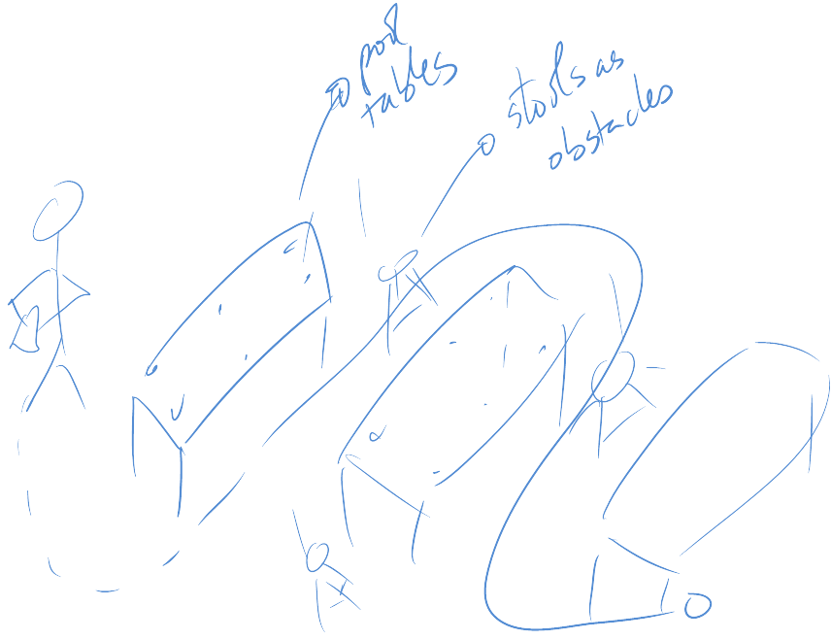
Figure 5 – Participant doing the experiment in a pool hall with players and stools as obstacles. They were asked to follow a certain path. The task involved whacking as many moles as possible over the course of the path.
that ere provided the battery pack on

Results

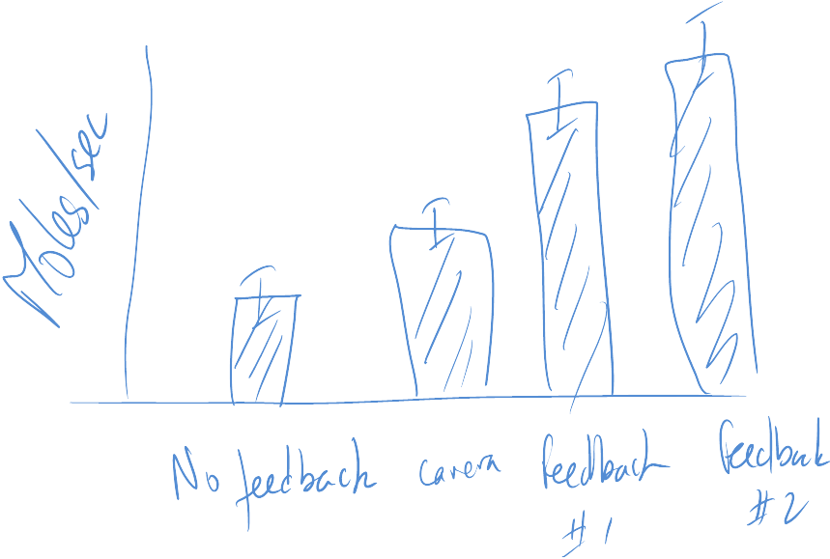

Discussion
Our informal observations and user feedback support the use of CrashAlert in avoiding daily encountered obstacles while multi-tasking on the mobile phone. Users were able to dodge passer-bys or ensure reliable avoidance while multi-tasking. We discuss our overall observations, the limitations of our current system, and provide some recommendations to designers.

Design Space
The design of CrashAlert is influenced by these four dimensions: peripheral window selection, choice of visual feedback, capture of moving objects, and …

Abstraction
- Sensor data
- Video
Window Selection
- Tilt
- Scanning for …
Presentation
- Continuous
- Discrete
- Literal
Information Delivery
- Always On
- Implicit Interaction [when it detects the user walking or then it senses obstacles approaching]
Notification Mechanism
- Visual Alerts
- Vibration
- Sound
The following table summarizes our design space definition, pointing out the particular configuration for our CrashAlert prototype and highlighting places for further exploration.
Dimension | Types of Values
Abstraction | Sensor |  |  | Video
Window Sel | Fixed |  | Tilt |  | Scanning
Presentation | Continuous | Discrete |  |  | Literal
Inf Delivery | Always On | Explicit |  |  | Implicit
Notific. Mech | Visual | Haptic |  |  | Sound

FOV mismatch
With these existing systems little is known about how much overlap exists between the user’s field of view and the camera’s field of view, i.e in other words the two FoVs overlap and are not complementary.

Depth Feedback Assists in Obstacle Avoidance

Effect of Visual Feedback on Obstacle Avoidance

Object Overlays Show Improved Performance

Policies
Talk about government policies. Perhaps policies can enforce that texting and walking be done only if users use systems such as BumpAlert to help avoid obstacles. Much testing is however necessary before such policies can be instilled.

Limitations

Recommendations to Designers

Soft

Conclusion

REFERENCES

- http://money.msn.com/auto-insurance/article.aspx?post=a8b7daf9-5e31-4cd1-a9c7-ca3979b7abc2

- How to Classify Works Using ACM’s Computing Classification System.
http://www.acm.org/class/how_to_use.html.
- hello
- Cole, William G.Understanding Bayesian Reasoning Via Graphical Displays. In Proceedings of CHI'89 Human Factors in Computing Systems (April 30–May 4, Austin, TX), ACM/SIGCHI, NY, 1989, pp. 381–386.
- Gary, M.R. Optimal binary identification procedures. SIAM J. Appl. Math. 23, 2 (Feb. 1972), 173–186.
- Garey, M.R. and Johnson, D.S. Computers and Intractability: A Guide to the Theory of NP- Completeness. Freeman, San Francisco, CA, 1979.
- Schwartz, M. Guidelines for Bias-Free Writing. Indiana University Press, Bloomington, IN, USA, 1995.

The columns on the last page should be of approximately equal length.

